### Experience:

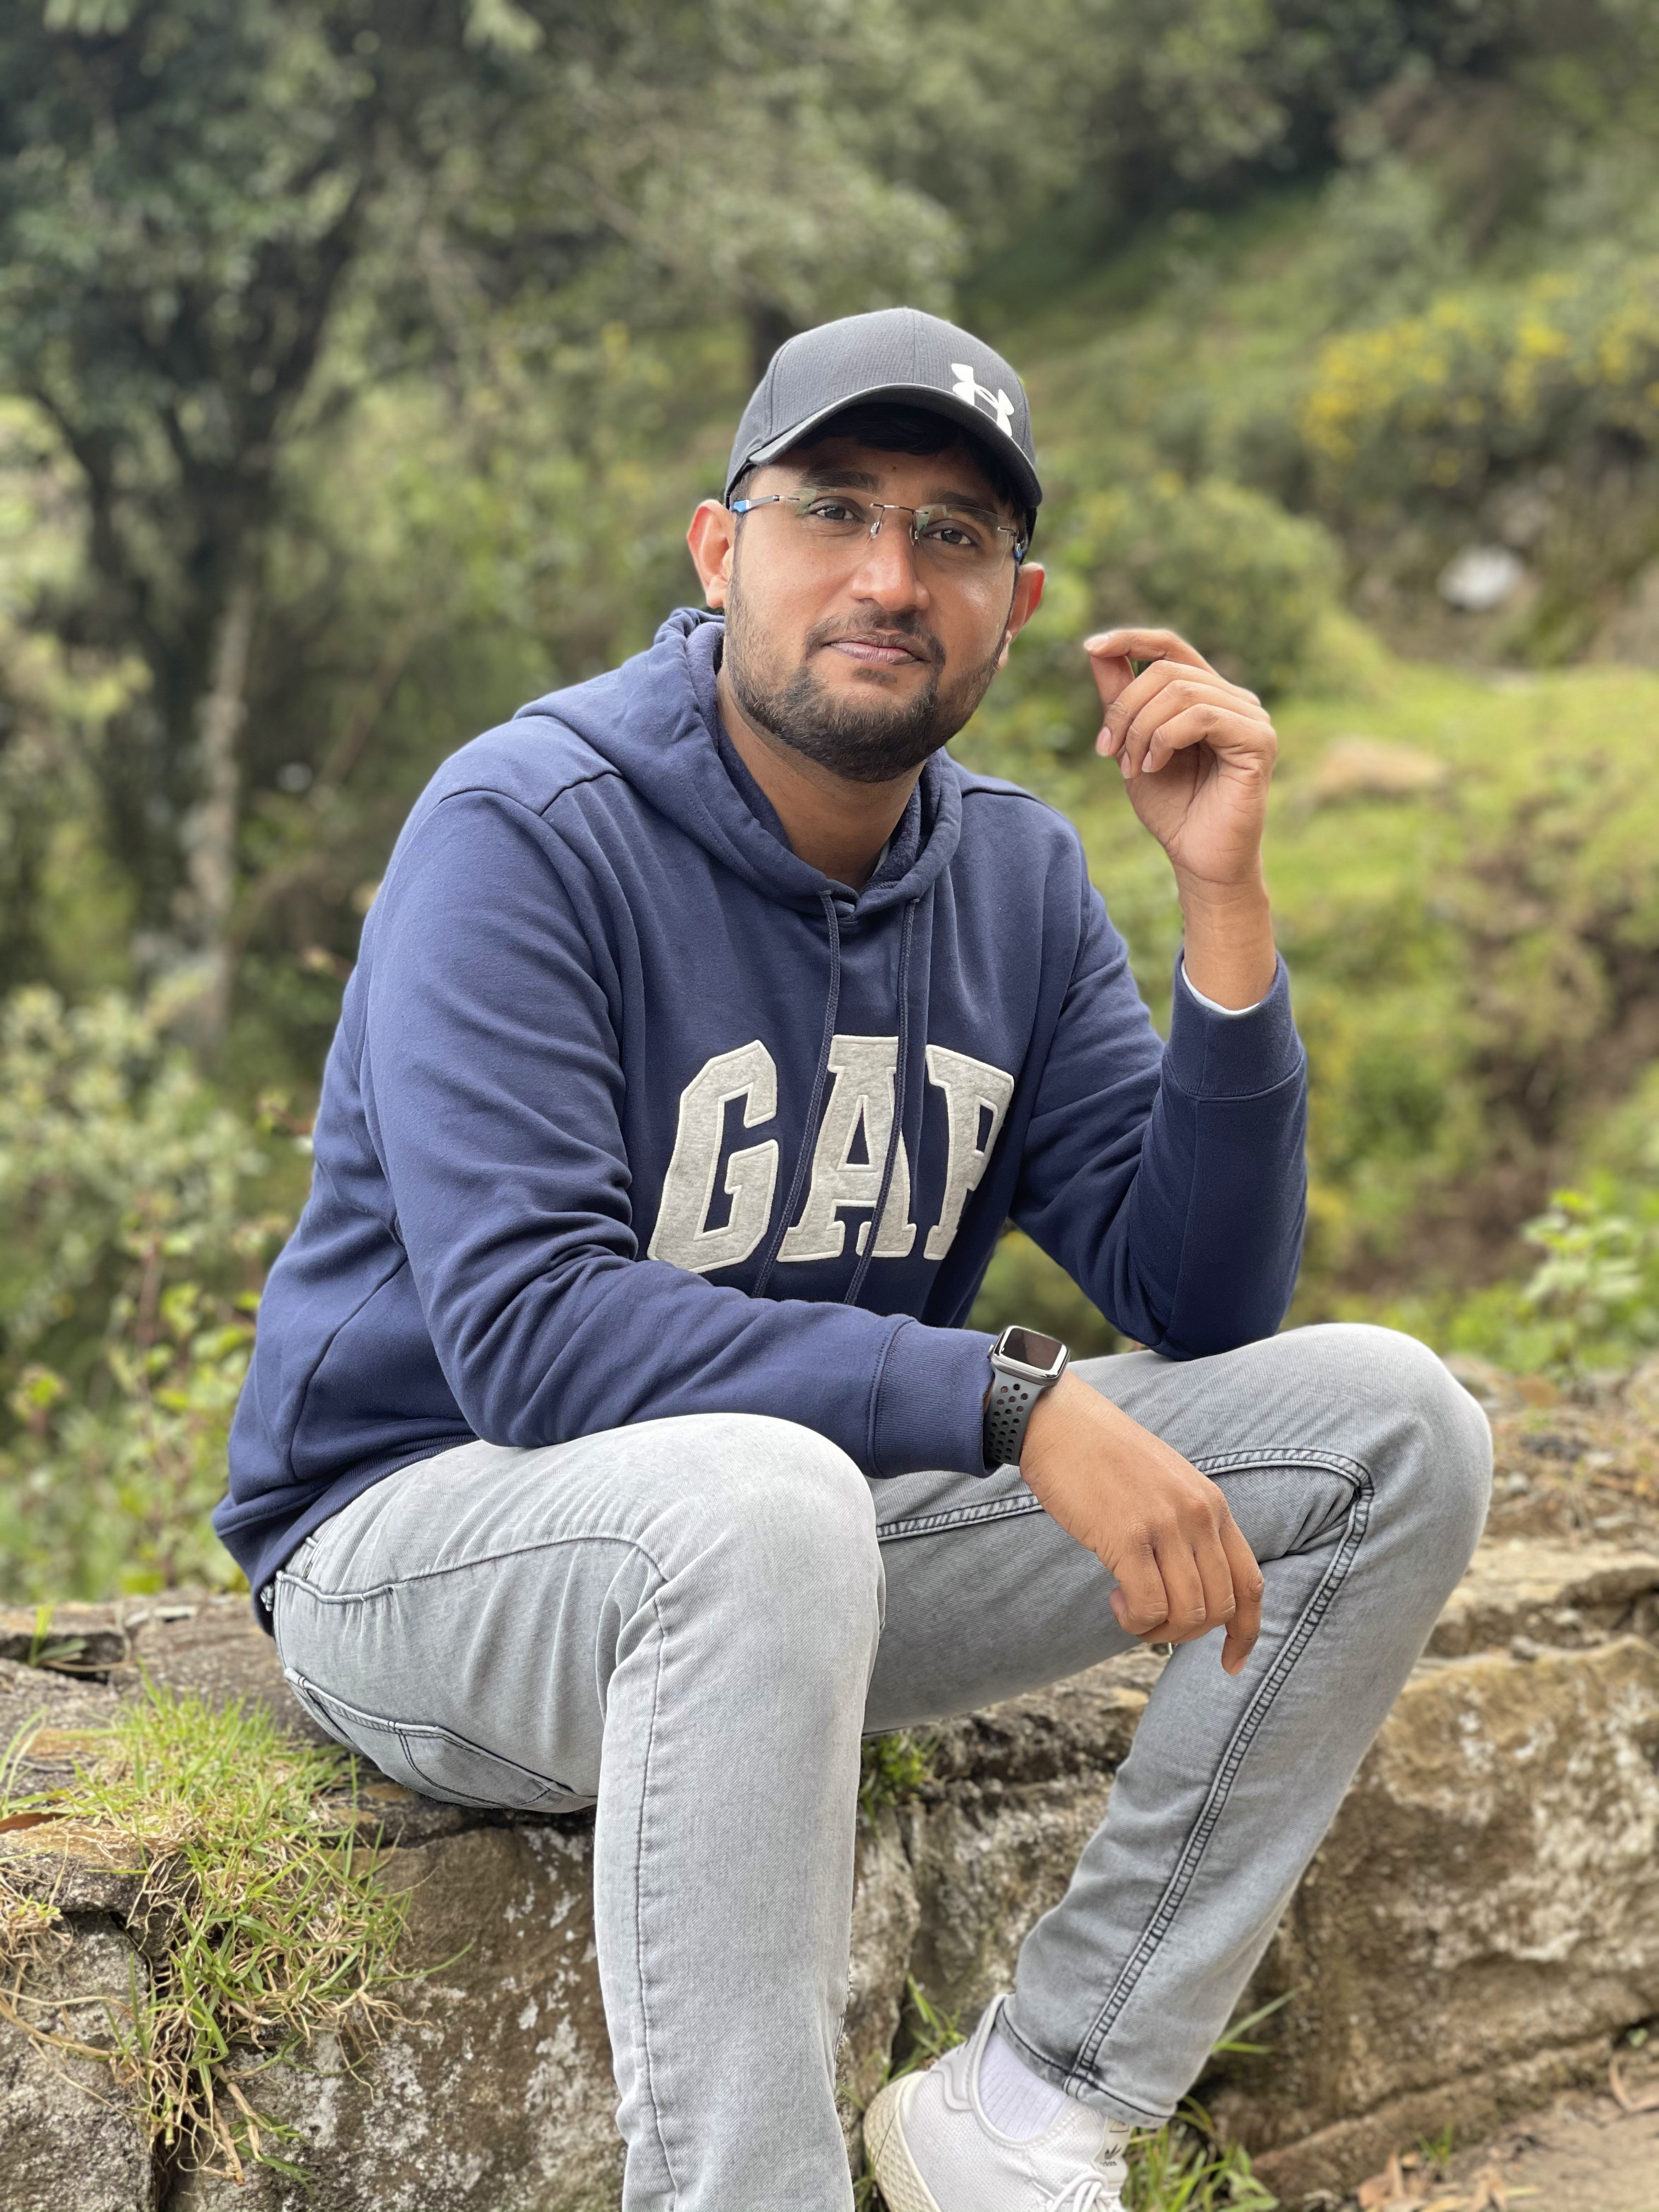

## contact

madhurakshith15@gmail.com

narasimm1@hawkmail.newpaltz.edu

LinkedIn Profile:

[linkedin.com/in/madhu-rakshith-narasimharaju-5a924912a](https://www.linkedin.com/in/madhu-rakshith-narasimharaju-5a924912a?lipi=urn%3Ali%3Apage%3Ad_flagship3_profile_view_base_contact_details%3By6c0P%2BA%2FTDi6SA%2Bovye3jQ%3D%3D)

(845)-282-0423

36, colonial dr Apt E, New paltz, Ny-12561

I have done my undergrad in mechanical engineering. After that I have worked as a full stack developer under technologies like METEOR.JS(I have used Blaze for frontend), Node Js, MongoDB, MYSQL, PostgreSQL, React, React Native, Blaze, Javascript, CSS3, HTML, J query and Bootstrap.

I have built mobile apps using Cordova platform.

I have built a complete web application using Meteor.Js (A javascript frame work)

The references have been given below for web application and mobile applications:

Web application:

* http://my-pop.co.uk/
* http://www.navietm.com/

iOS app:

* https://itunes.apple.com/in/app/mypop/id943510047?mt=8

Android app:

* https://play.google.com/store/apps/details?id=com.nvbr22gmailcom.mypopapp

### Course Learning objective:



MADHU RAKSHITH NARASIMHARAJU

From the course I would like to boost up my skills and knowledge with working on new application which will be a part of the course, additionally I will be working on VUE an front end frame work where I Don’t have hands on yet, which will be added as one more feather to my cap.

Also, I can brush up all my Javascript based technologies along with learning a new framework will be an plus point.